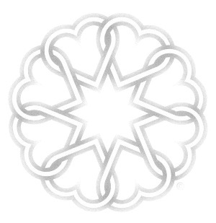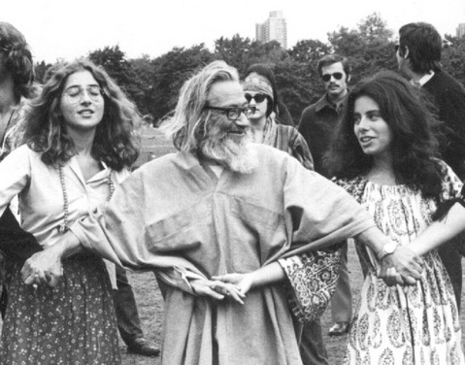

A GLOBAL DANCE CELEBRATION

24 June 2018

On 24th of June 1968, Murshid SAM introduced the first Dance of Universal Peace (DUP). Since then our beloved Dances and Walks have grown a global family and have filled our lives with real experiences of peace, harmony and beauty. We have a lot to be grateful for and a lot to celebrate! Let's do it together as a global family:

On Sunday, 24th of June 2018, marking 50 years of DUP, lets all dance on that same day (if not possible, that same weekend or same moon) in a global dance celebration. Thousands of dancers, dozens of countries, all our circles synchronized in the same intention, song and movement.

For information on how to get involved please see

[www.dancesofuniversalpeace.org](http://www.dancesofuniversalpeace.org)

**Peace and Harmony among Nations and Traditions**

50th Anniversary of the

Dances of Universal Peace